**USER’S**

**MANUAL**

***ONLINE COUNSELLING APPOINTMENTBOOKING SYSTEM***

**USER'S MANUAL**

**TABLE OF CONTENTS**

# GENERAL INFORMATION

General Information section explains in general terms the system and the purpose for which it is

Intended.

## System Overview

Online Counselling Appointment Booking System is an application that manages the appointments at the Deans office. A system that will allow students book appointments to see counsellors and the dean of Students in Egerton University Njoro Campus. It will operate in windows/Unix Environment and will be web based system. The system should be able to lift data from existing student’s portal database.

## Organization of the Manual

The user’s manual consists of five sections: General Information, System Summary, Getting Started, troubleshooting and support. General Information section explains in general terms the system and the purpose for which it is intended. System Summary section provides a general overview of the system. The summary outlines the uses of the system’s hardware and software requirements, system’s configuration, user access levels and system’s behavior in case of any contingencies. Getting Started section explains how to get OCABS and install it on the device. The section presents briefly system menu and provides a detailed description of system functions. Troubleshooting and support section helps a way of troubleshooting and seeking help whenever the problems are encountered.

# SYSTEM SUMMARY

System Summary section provides a general overview of the system. The summary outlines the uses of the system’s hardware and software requirements, system’s configuration, user access levels and system’s behavior in case of any contingencies.

## System Configuration

OCABS operates on both windows and UNIX operating system. The application requires connection to Internet in order to save data to database, book appointments, set schedules, print schedules and approve the schedules. The appointments and schedules can be viewed using any major internet browsers. After installation on the device, OCABS can be used immediately without any further configuration.

## User Access Levels

Only registered users are supposed to interact with the system, where the students book appointments to see the counsellor, the counsellor to set schedules and the dean to oversee all the activities.

## Contingencies

In case of no internet a student cannot book the appointment.

# GETTING STARTED

Getting Started section explains how to get OCABS and install it on the device. The section presents briefly system menu.

## Set – up consideration

To optimize your access to the OCABS application:

* Make sure that the computer or smartphone has the internet access.
* Use the internet browsers e.g*. Chrome, Firefox, Internet Explorer.*

## Accessing the system

To access the system:

1. Open your favorite web browser.
2. Type in the search bar the URL of the system in the search bar (<http://127.0.0.1/Online-Appointment-Booking-System/>).

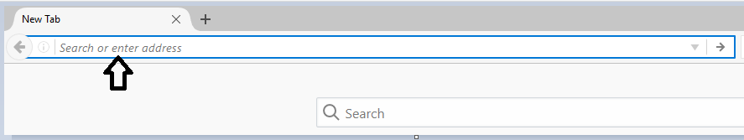

*Figure 1 search bar to input the URL of the system.*

1. To log in the system, students to provide their registration numbers and the password. The counsellor to give out the password and the counsellor number and the dean to provide the password.

### System Organization & Navigation

The functions of the system are described in the system menu below:

After entering the URL of the system in the web browser, the following page appears:

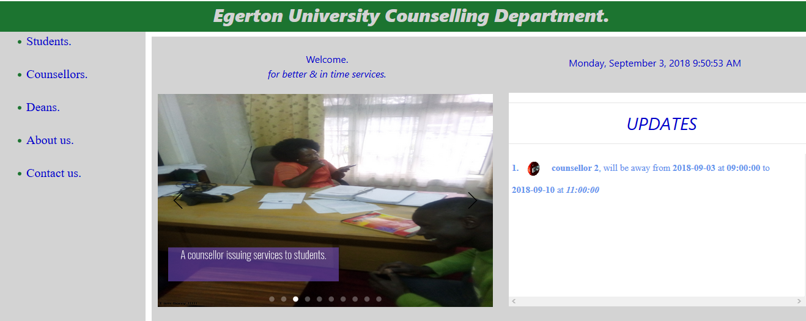

The respective users to select their section.

## Student activities

* + 1. **Student log in**

For students, choose the student section. If registered you can log in in the window below on the left of the screen. And if unregistered you can register as the new user. In case of the forgotten password, click the “forgot password?” link below the sign up and sign in tabs.

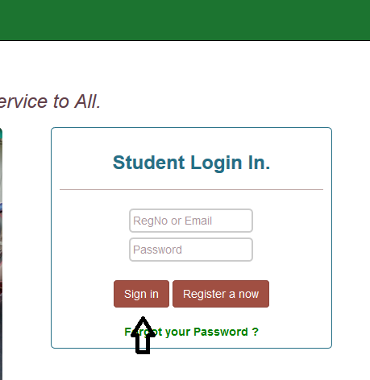

After a successful log in , a page appears with four tabs [Home](http://127.0.0.1/Online-Appointment-Booking-System/student.php) ,[Book Appointment](http://127.0.0.1/Online-Appointment-Booking-System/studentbookappPage.php) ,Booked Sessions, [Logout](http://127.0.0.1/Online-Appointment-Booking-System/students/logout.php) .When you select Home tab you maintain the same page.

* + 1. **Booking Appointment**

You can select Book Appointment tab to proceed to the bookings.

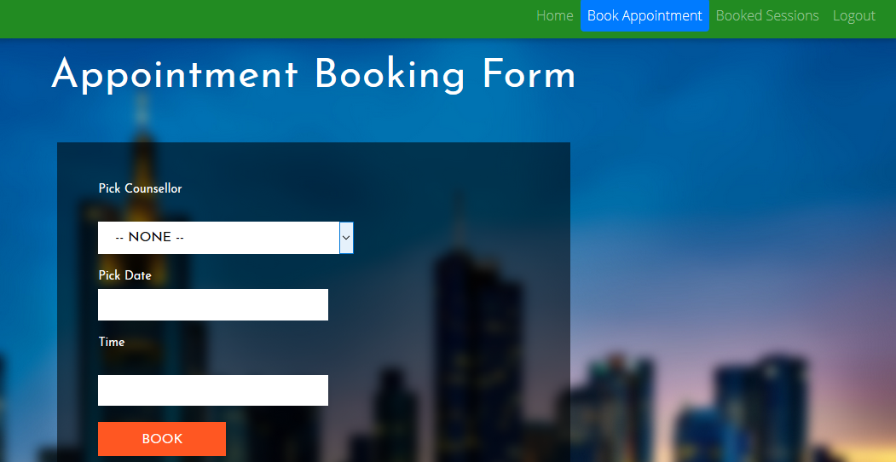

The student is required to pick the counselor, pick date and pick time. Finally click the book tab complete the booking process.

* + 1. **Viewing booked sessions**

When you want to view the booked sessions, click the tab “Booked Sessions”

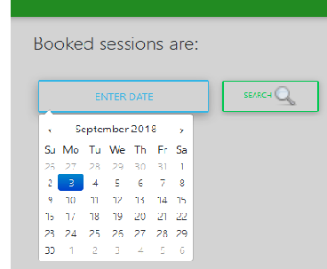

On the page enter the date dates you want to view the sessions booked and then click search icon to extract the sessions.

When done with the functions you can logout by clicking the logout tab. The page will redirect you back to the log in page**.**

## Counsellor activities

* + 1. **Counsellor log in**

On the main page click the Counsellor link. A log in page will pop up.

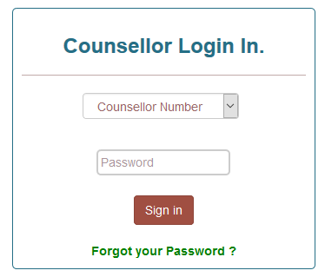

Select the Counsellor Number. Enter the password and click “Sign in” button to log in Incase you forget your password, click the “Forgot your Password?” link to reset the password.

After a successful log in the following page should appear. It has three tabs” home, View Appointments, Set Schedule and log out”

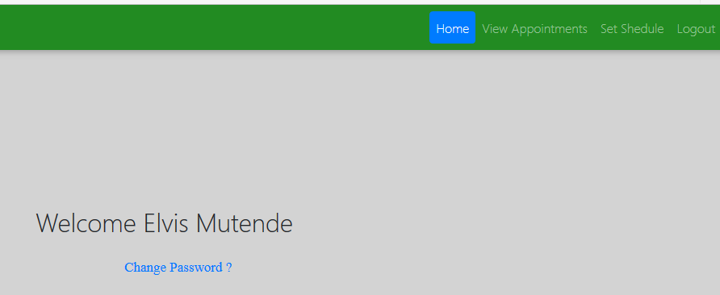

* + 1. **Counsellor change password**

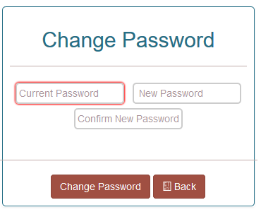

By any case you want to change the password, click the “Change Password?” link. You will be redirected to the following page. You are required to provide the current password, new password and then confirm the new password. Finally click the Change Password tab to complete the process. Back tab for getting you back to the Counsellor’s home page.

* + 1. **View Appointments**

To view the appointments click the “View Appointments” tab. You will be required to input the date and then click the search icon to search the appointments.

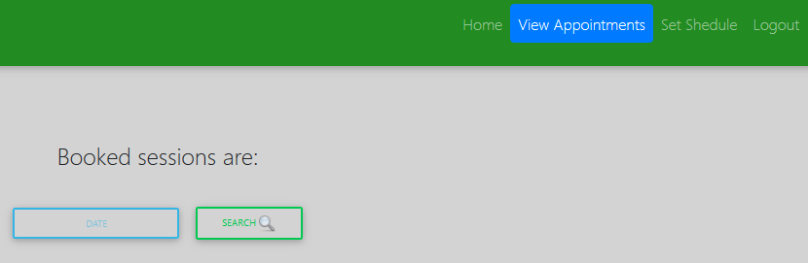

* + 1. **Set Schedule**

On the page, select the date you will be away ,time to be away, number of hours to be away and the days to be away. You are also required to give the reason for being away. Finally click the “Set” button to set the schedule.

In case you want to set the schedule click the “Set Schedule” tab.

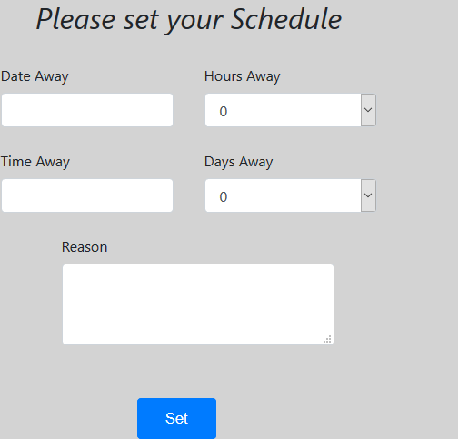

## Dean Activities

* + 1. **Dean log in**

On the main page, select the “Deans “link that will take you to the log in page, where the dean is supposed to log in.

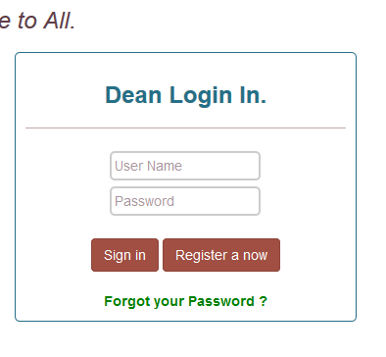

Provide the username and password if already registered. Click “register now” to register or click the “Forgot your Password” to reset the password.

After a successful log in you will be directed to this page.

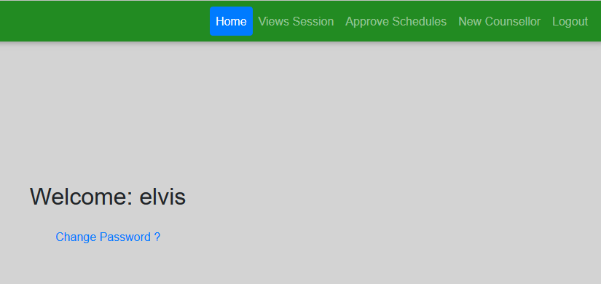

It has five tabs([Home](http://127.0.0.1/Online-Appointment-Booking-System/dean/dean.php?msg=logged%20in%20Successfully) ,[Views Session](http://127.0.0.1/Online-Appointment-Booking-System/dean/viewsessionsPage.php), [Approve Schedules](http://127.0.0.1/Online-Appointment-Booking-System/dean/approveschedulePage.php) ,[New Counsellor](http://127.0.0.1/Online-Appointment-Booking-System/counsellors/counsellorSignupPage.php) ,[Logout](http://127.0.0.1/Online-Appointment-Booking-System/dean/backend/logout.php) )

Home button directs you to the home page

* + 1. **Dean change password**

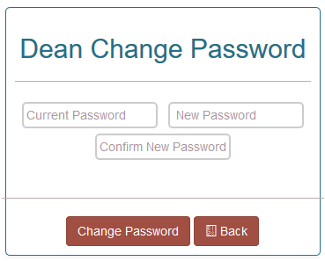

By any case you want to change the password, click the “Change Password?” link. You will be redirected to the following page. You are required to provide the current password, new password and then confirm the new password. Finally click the Change Password tab to complete the process. Back tab for getting you back to the Dean’s home page.

* + 1. **Views Sessions**

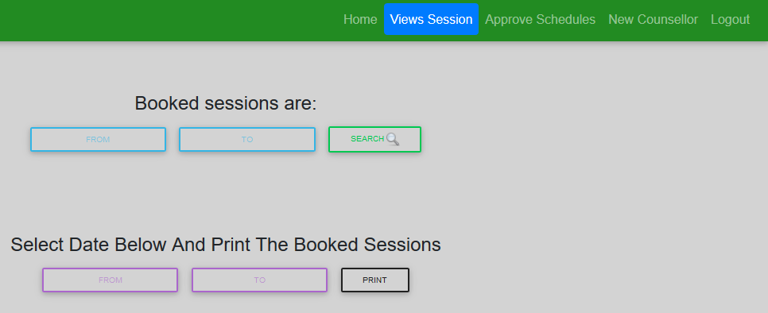

To view sessions, click the views session tab .To filter the sessions at specific dates, enter the first date and the second date .Click the search icon to search the sessions currently in the system.

* + 1. **Print sessions**

To print the booked sessions enter the start date and the last date then click the print button to print out the booked sessions in PDF format.

* + 1. **Approve schedules**

To approve the sessions click the approve session tab.

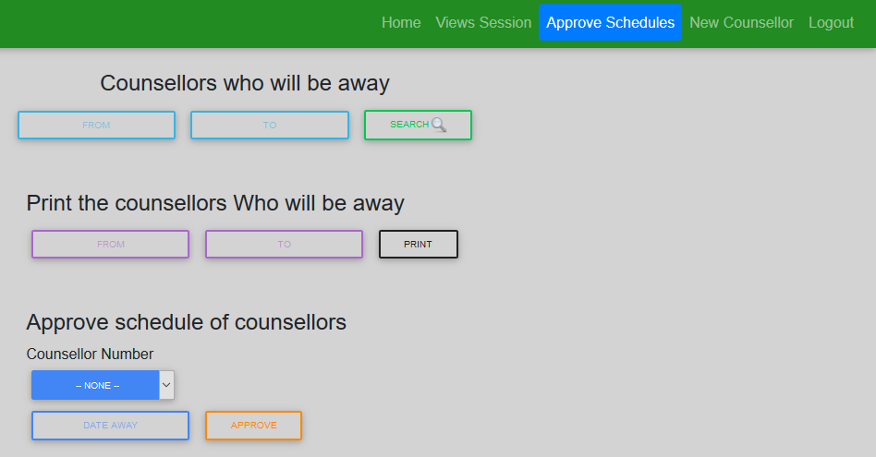

When you want view the counsellors who will away, input the two dates within which the counsellors are set to be away and click the search icon to retrieve the counsellors to be away on those dates.

* + 1. **Print counsellors away**

You can also print the counsellors who will be away by inputting the two dates and click the print button.

To approve the schedules for the counsellors who will be away, select the counsellor number and the date he/she will be away and then click the approve button.

* + 1. **Register the counsellor**

The dean can also create a new counsellor by clicking the New Counsellor.

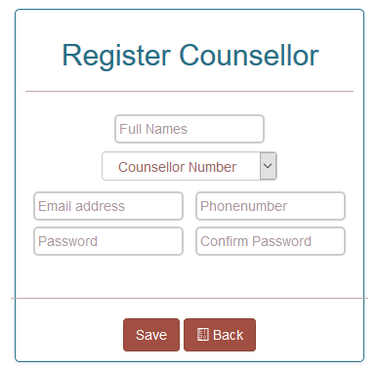

Provide the full names of the counsellors. Select the counsellor number. Provide the Email address, phone number and the default password for the counsellor. Click save button and back button to take you back to the home page of the dean.

## About us

To get the information about the department click the about us link on the main page.

## Contact us

It gives detailed information on how to reach the help desk.

## Exiting the System

To exit the system, all users of the users are required to sign out. Close the tabs of the web browsers. You would have exited the system.

# Troubleshooting and Support

In case of the problems with connectivity, contact the resource center stuff to sort out the internet problems.

**4.1.** Error Messages

The user is expected to receive error message when inputs the wrong password, user name or the email address.

**4.2.**Support

In case of the emergency assistance contact the following help desks.

Table 1 - Support Points of Contact

| Contact | Organization | Phone | Email | Role | Responsibility |
| --- | --- | --- | --- | --- | --- |
| Asst.Dean | Counselling Dept | **+254 0512217891/2** | dean@egerton.ac.ke | Assistant DOS | Student Welfare |

Appendix A: Acronyms

Table 2 - Acronyms

| Acronym | Literal Translation |
| --- | --- |
| OCABS | Online Counselling Appointment Booking System |
| PDF | Portable Document Format |
| DOS | Dean Of Students |

**Appendix C: Approvals**

The undersigned acknowledge that they have reviewed the User Manual and agree with the information presented within this document. Changes to this User Manual will be coordinated with, and approved by, the undersigned, or their designated representatives.

Table 3 - Approvals

| Document Approved By | Date Approved |
| --- | --- |
| Name: <Name>, <Job Title> - <Company> | Date |
| Name: <Name>, <Job Title> - <Company> | Date |
| Name: <Name>, <Job Title> - <Company> | Date |
| Name: <Name>, <Job Title> - <Company> | Date |